**Python Turtle Graphics Example:**

: We have created some turtle example.

1] printing square :

Code:

#python program to create

import turtle

t=turtle.Turtle()

turtle.bgcolor("black")

turtle.pencolor("green")

turtle.pensize(10)

for i in range(4):

turtle.forward(100)

turtle.right(90)

turtle.done()

Output :

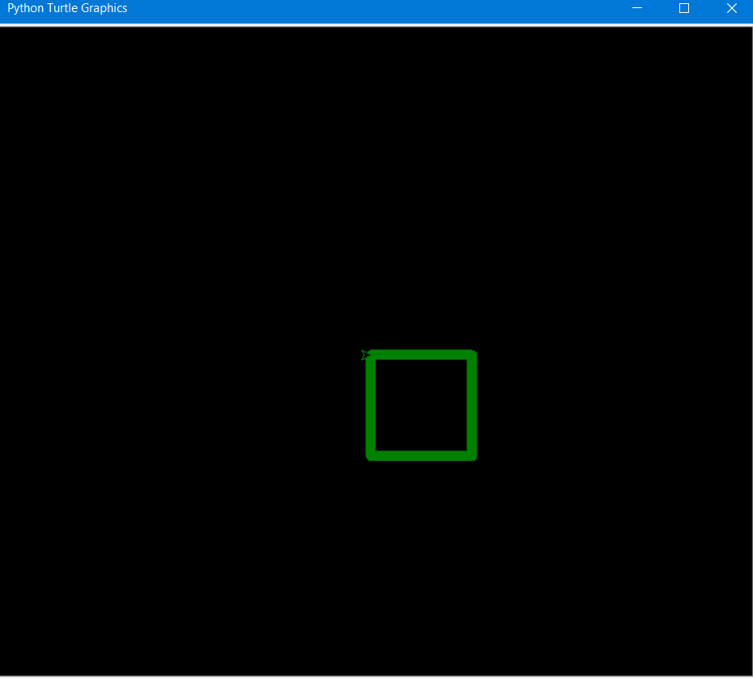

2] Printing Vibrating Circle :

Code :

import turtle

t=turtle.Turtle()

s=turtle.Screen()

s.bgcolor("black")

t.pencolor("orange")

a=0

b=0

t.speed(0)

t.penup()

t.goto(0,200)

t.pendown()

while True:

t.forward(a)

t.right(b)

a+=3

b+=1

if b==210:

break

t.hideturtle()

turtle.done()

Output :

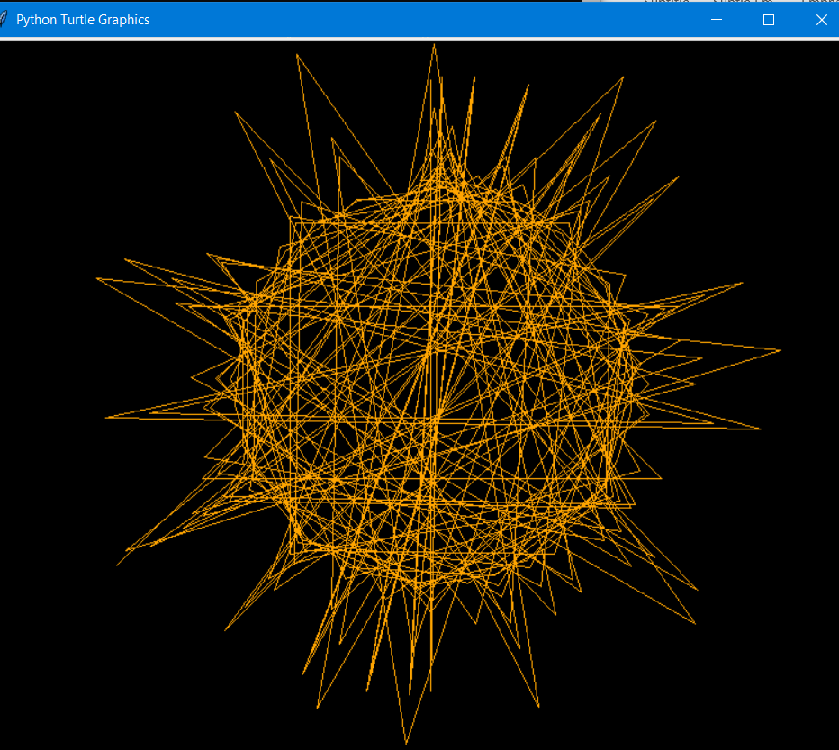

3] printing Square Design :

Code :

import turtle

t=turtle.Turtle()

turtle.bgcolor("black")

turtle.pensize(5)

turtle.pencolor("white")

turtle.title("Title")

turtle.speed(0)

turtle.penup()

turtle.right(90)

turtle.forward(200)

turtle.left(90)

turtle.forward(100)

turtle.pendown()

for i in range(10):

turtle.left(80)

turtle.forward(310)

turtle.left(175)

turtle.forward(310)

turtle.right(175)

turtle.forward(310)

turtle.done()

Output:

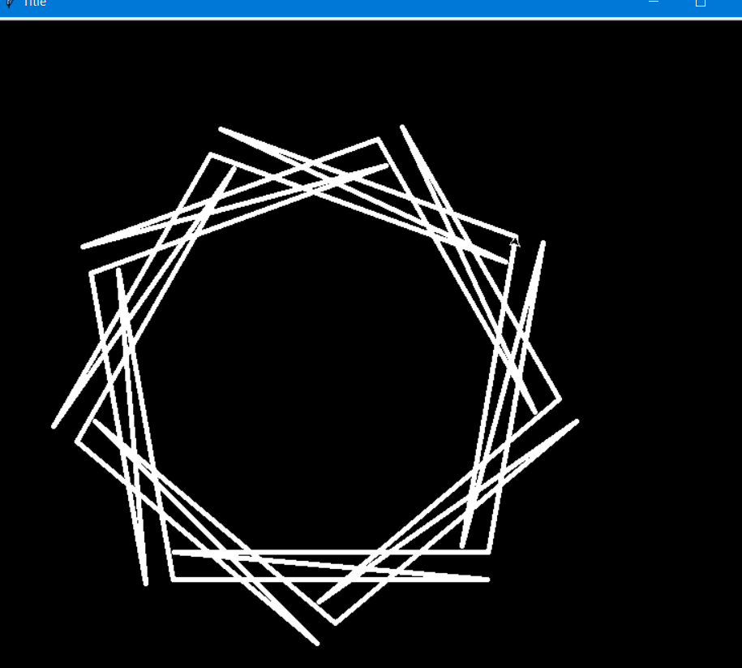

4] Printing Helix :